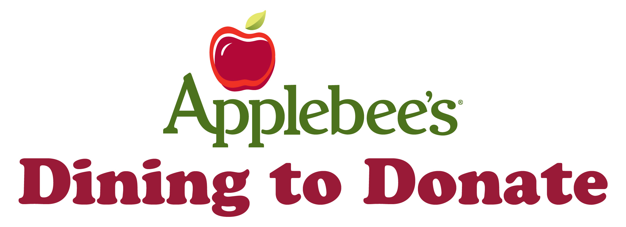

Dear Participating Organization,

Your organization is an important part of our community.

In a continuing effort to support worthy neighborhood causes, Applebee’s invites you to participate in our “Dining to Donate” fundraiser program. “Dining to Donate” is a fun and easy way for Applebee’s to assist you in raising funds for a cause or organization of your choice. We will provide our restaurant, staff, and a Dining to Donate flyer to ensure that your “Dining to Donate” event is an absolute success. When your friends and family hand in your organization’s “Dining to Donate” event flyer on the day of the event, 10% of their purchase will be donated directly back to your organization.

Attached you will find some helpful information to get you started:

- Dining to Donate in Five Easy Steps
- Dining to Donate Policies
- The Six Keys to a Successful Dining to Donate
- Frequently Asked Questions

We thank you for choosing Applebee’s, and we wish you the best of luck in your fundraising efforts. Please contact me with any additional questions.

Your friends at Applebee’s.

DINING TO DONATE IN 5 EASY STEPS

 | Find a great cause to raise funds for (class trips, schools, Boy Scouts of America, Relay for Life, athletic teams, service trips, clubs, PTAs, etc.).  Schedule your event on Flapjackfunds.com.  Advertise, advertise, and advertise! Consult “The Six Keys to a Successful Dining to Donate” for more information.  Enjoy a great meal during your Dining to Donate event with all of your friends and family.  Receive your donation check within 4 to 6 weeks of your event.

DINING TO DONATE POLICIES

Applebee’s will donate 10% of any check on your specific day (excluding tax, alcohol sales, and gift card sales) that is accompanied by a valid Dining to Donate flyer for your group/organization.

Guests may dine in, or take out food (not valid in all locations) for the fundraiser. As long as they have a flyer with them, their donation will be counted!

Dining to Donates are hosted Monday through Thursday only. (Days may vary per location).

Only a valid Dining to Donate flyer will be counted for donation.

Flyers must be distributed prior to the event night. You may NOT stand outside the restaurant and hand out flyers to customers entering the restaurant. If your organization distributes flyers during your event, no funds will be donated and your event will be canceled. The restaurant will not supply additional flyers for your Dining to Donate on the day your event is hosted.

SIX KEYS TO A SUCCESSFUL DINING TO DONATE EVENT

Schedule at Least 4 Weeks in Advance
Schedule your Dining to Donate at least four weeks in advance. Four weeks provides you an ample amount of time to properly promote your event.

Print the Official Handout
Once your Dining to Donate flyer is e-mailed to you, print, and distribute to all of your family and friends. This is the only flyer that will be valid.

E-mail Blast
E-mailing Dining to Donate flyers to your family and friends is the quickest and easiest way to create buzz and generate interest in your event. Simply attach the file to your e-mail and send away. Once your e-mail is sent, all your friends and family need to do is print it out!

Give Reminders 48 Hours Before the Event
Two days before your Dining to Donate, remind your family and friends of the event. They will already have the flyer and have it marked on their calendar, but hearing your voice will motivate them to attend.

Encourage Friends and Family to Bring One Person Each
This is the easiest way to double your donation total. If you know one of your friends or family member is attending, encourage them to bring one more person with them.

Experiment with Unique Advertising Techniques
In addition to distributing and e-mailing flyers, try a unique advertising technique such as inserting your flyer into the school newspaper, weekly newsletters/e-newsletters, or even uploading the flyer to Facebook or your blog. Make your flyers stand out by printing them on brightly colored paper like orange or neon green. Remember, all guests MUST have a printed copy of the flyer with them and distributing flyers on Applebee’s property is strictly prohibited.

FREQUENTLY ASKED QUESTIONS

Q: How much money will I raise?
A: The average check at Applebee’s is $15.00 per person. 10% of a $15 check translates into a $1.50 donation. You can estimate your total by dividing your monetary goal by 1.5. For example, if $250 is your donation goal, you need 167 people (250/$1.5) to attend your event. Please note that this method is only a way of estimating your total.

Q: When will I receive my check?
A: Your check will be directly mailed to the address you provided to the Applebee’s manager within four to six weeks of your event date.

Q: My event was a success! Can I do it again?
A: Of course! You can schedule the date on and time on Flapjackfunds.com.

Q: My event did not go as well as I thought. What did I do wrong?
A: Groups do not receive their ideal turnout due to a lack of marketing. If you try again, please utilize “The Six Keys to a Successful Dining to Donate.”

Q: Who should I contact for additional questions?
A: Please speak to the General Manager at the Applebee’s location that is hosting your Dining to Donate event.

